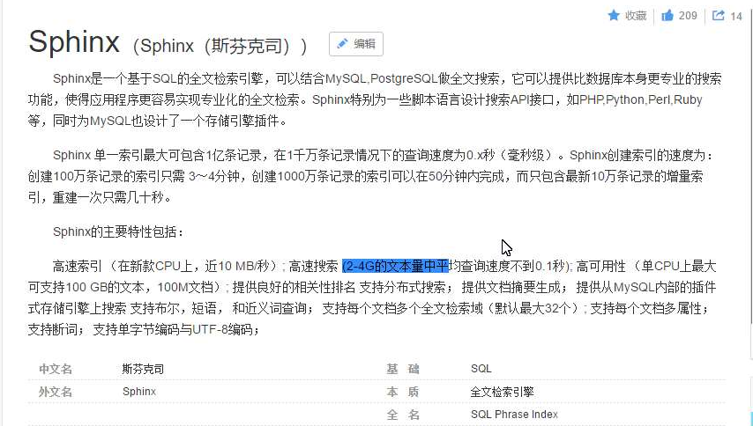

https://blog.csdn.net/yingzheng1983/article/details/52161822
http://www.sphinxsearch.org/sphinx-tutorial
http://blog.jobbole.com/101672/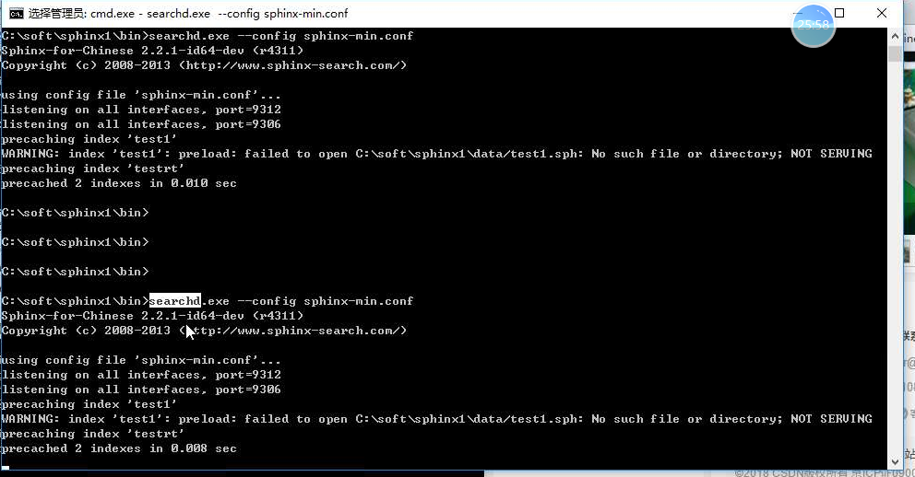

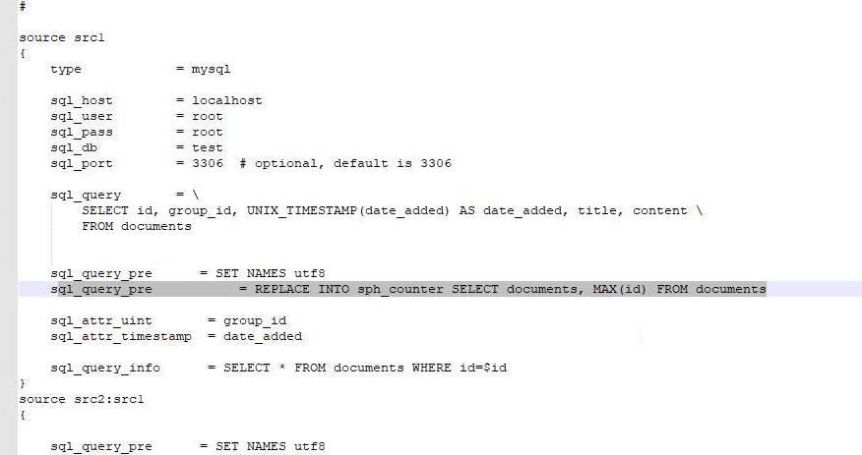
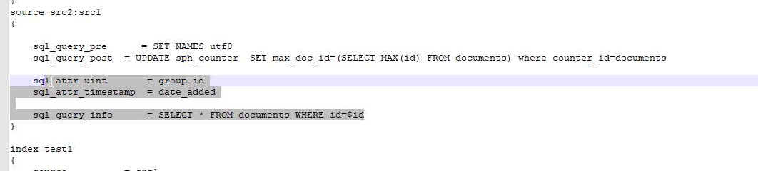增量索引的资源
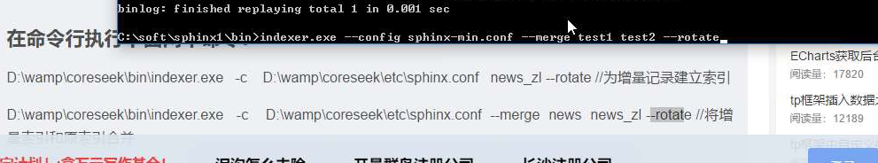
索引合并
https://www.cnblogs.com/mingaixin/p/5085708.html
https://blog.csdn.net/nuli888/article/details/51892776
https://blog.csdn.net/zuimei_forver/article/details/49951299

